**TASKS REPORT**

**Name:- Kundan Keshav Gawande  
 Wipro_id:- 28806**

**DATE:- 09-06-2025**

**Trainer:- Tapan Sir**

**Traffic Analysis In Windows Server Using Wireshark**

* **HTTP Traffic:-**

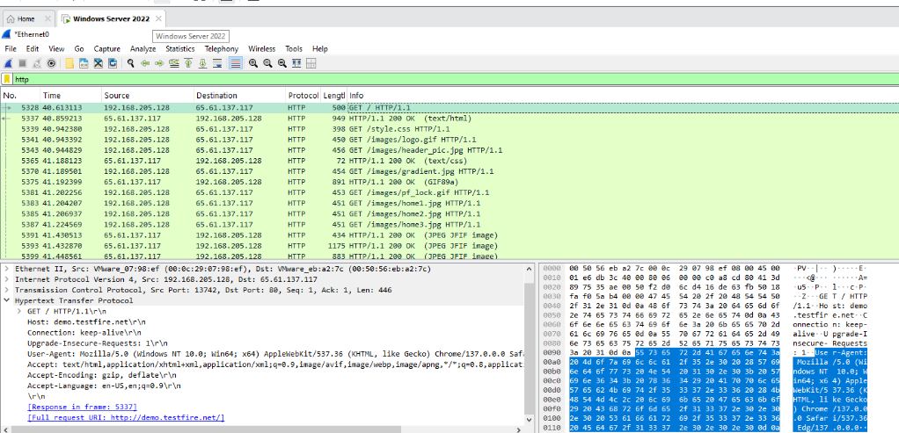

* **HTTPS Traffic:-**

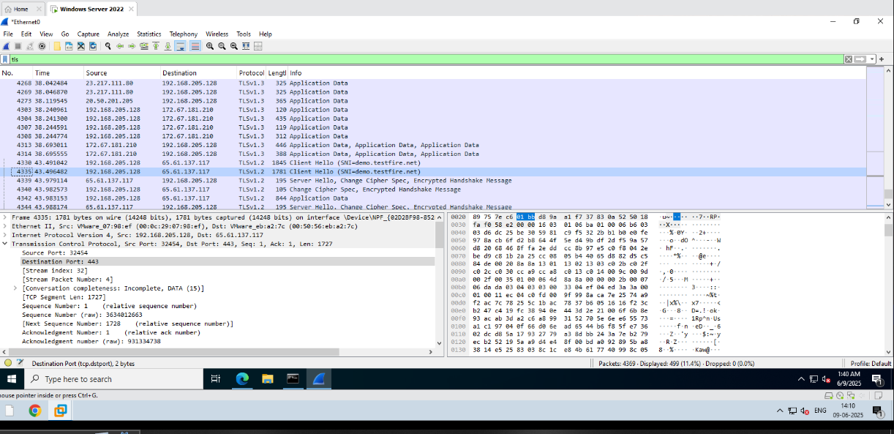

* **ICMP:-**

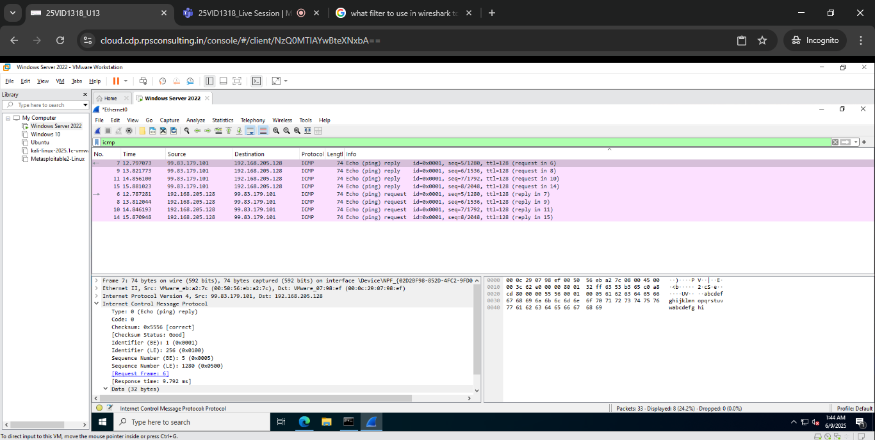

* **DNS:-**

